Church Newsletter

Barbecue Presbyterian Church

APRIL 2021



In Matthew’s account of Jesus’ resurrection, the two Marys are told to tell the disciples: “He has been raised from the dead, and indeed, he is going before you to Galilee. There you will see him.” (see Matthew 28: 1-10)

Galilee is in the northeastern region of Israel. But Galilee, according to the resurrection narratives, is really any place where the risen Christ appears, where the love of God abounds.

Galilee is your home where you experience the love of family.

Galilee is the hospital where staff deliver gifts of compassion and care to patients.

Galilee is grocery stores where stockers replenish shelves with food.

Galilee is assisted living facilities where unsung staff compassionately meet the needs of residents.

In all those places and people, the risen Jesus appears, the light of God’s love shines.

The truth of Easter is realized in the appearance of the resurrected Jesus, who meets us in the Galilees of life. As someone has said: “It is a truth born and nurtured in the heart of God; the truth that God loves us with an everlasting love, a love that will not die, a love that puts the risen Jesus in our midst.” (Tom Are, pastor of Village Presbyterian Church, Prairie Village, Kansas)

Joyfully,

David

Joanna Adams, Good News Indeed, Journal for Preachers, Easter, 2004, p. 40.

Page 2

Church Newsletter

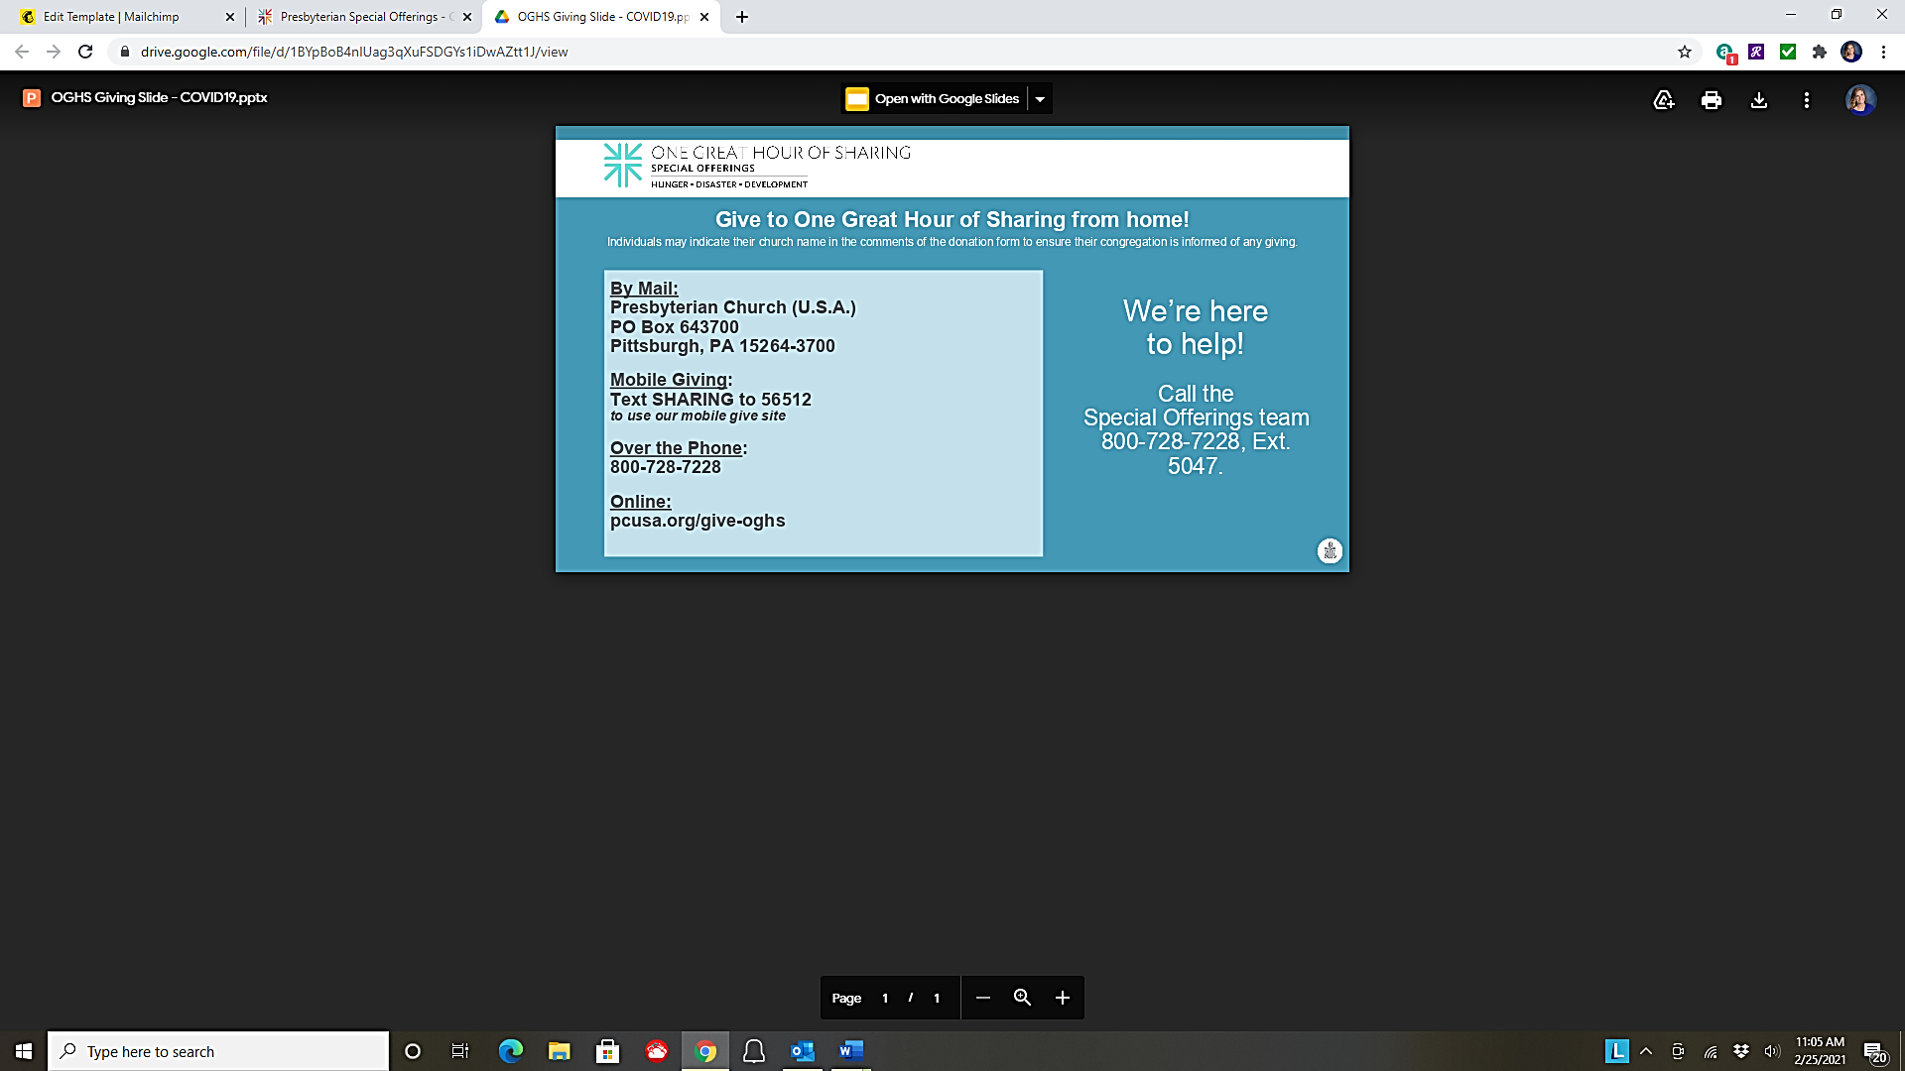

# One Great Hour of Sharing

This Special Offering occurs Easter, April 4th. A gift to One Great Hour of Sharing enables the church to share God’s love with our neighbors-in-need around the world by providing relief to those affected by natural disasters, provide food to the hungry, and helping to empower the poor and oppressed.

Barbecue Presbyterian Church is inviting you to a scheduled Zoom meeting.  
<https://us02web.zoom.us/j/84429006352?pwd=WVNXY1d6N1AxcWhVOG8wMDJwN1pidz09>  
Meeting ID: 844 2900 6352  
Passcode: BbqChurch

# Zoom Information for Worship

Please make sure you use the URL under "Join Zoom Meeting" below. If you cannot get on please call my cell phone number (shown below).  
[https://us02web.zoom.us/j/6674559286?pwd=e GZ2OHJPWW5vOFBoUTlVVnFpdUFBdz09](https://us02web.zoom.us/j/6674559286?pwd=e%20GZ2OHJPWW5vOFBoUTlVVnFpdUFBdz09)  
Meeting ID: 667 455 9286 Passcode: BbqChurch  
If you run in to problems call  
Dennis McLean Cell: (910) 494-4684

# Zoom Information for Sunday School

HIGHLIGHTS OF SESSION MEETING – March 17, 2021

**Treasurer Report:**

**February Income:** $ 12,361.31 **YTD Income** $ 21,706.31

**February Expense** $ 11,464.64 **YTD Expenses:** $ 22,058.29

**February Net Income** $ 896.67 **YTD Net:** $ - 351.98

**Approved:** (1) Rev. Sherrod vacation April 12-April 18; (2) Rev. Mary Mowrey as guest preacher April 18; (3) Youth volunteer for church project; (4) Salary increase for Choir Director position to $700/monthly; (5) Use of Fellowship Hall June 19th; (6) Bibles, hymnals and info cards to be placed back in pews **Heard:** (1) Report on Presbytery Clerk Training held virtual February 28 from Jane Sullivan; (2) Oscar Pace reported BPC now has deed from DOT for land across from church; (3)Committee reports and rosters

# Food Pantry

The Outreach Committee greatly appreciates the generosity of our congregation in supporting the Food Pantry ministry. There is a collection basket in the narthex to receive any food donations, such as "dry" good foods (i.e. canned foods, cereals, pastas)**.** Food bags are distributed on the 3rd Tuesday of each month from 10:00 AM – 11:00 AM in the fellowship hall. We greatly appreciate the generosity of our congregation in supporting this program. Our next distribution will be **Tuesday April 20th @ 10AM.** Come early and help with distribution!

# Outreach Food Pantry

# Camp Monroe Summer Camp 2021! Day Camp:

# Young Adult Job Opportunity

Time to Get Outside for the Summer!

You can swim, paddle, hike, and hammock & EARN MONEY this summer!

Join the Summer Camp team at Camp Monroe.  [www.monroecamp.org/jobs](http://www.monroecamp.org/jobs)

Counselors, Lifeguards, Support Staff, Cooks, Community Camp Leaders.

Ages 17 and up may apply.  Positions are filling, Apply now!

Ages 5-14 Trailblazers: Ages 6-8 Discovery Camp: Ages 8-11 Explorer Camp: Ages 12- 17 CIT: Ages 14-17

**Camp Calendar**   
June 13 – 18: Day Camp – Discovery Camp – Explorer Camp - Horse Camp   
June 20 – 25: Day Camp – Discovery Camp – Explorer Camp - Horse Camp CIT Session 1 - New in 2021: Grand Camp & Trailblazers   
June 27 – July 2: Day Camp – Discovery Camp – Explorer Camp - Night Owls   
July 11 – 16: Day Camp - Discovery Camp – Explorer Camp New in 2021: Rock, Raft, and Roll   
July 18 – 23: Day Camp – Discovery Camp – Explorer Camp New in 2021: Adventure Quest – CIT Session 2 July 25 – 30: Day Camp – Discovery Camp – Explorer Camp New in 2021: Grand Camp & Trailblazers August 1 – 6: Day Camp – Discovery Camp – Explorer Camp - Night Owls

**Grand Camp**: Looking for a memory that will last a lifetime? We offer Grand Camp for a wonderful grandparent and grandchild experience. For three days and two nights, campers of both generations enjoy activities together.   
  
**Summer Camp Open House**: June 6th 2:00pm – 5:00pm   
  
**Serve Day**: April 10th & May 22nd Open To All Ages We are gearing up for summer camp in 2021 and many hands makes light work! We will be tackling projects such as: raking, painting, and small construction items to help prepare us for our best summer camp yet!

**Summer Camp Registration is Open!**

We trust in Jesus Christ,

Fully human, fully God…

Unjustly condemned for blasphemy and sedition,

Jesus was crucified,

Suffering the depths of human pain

And giving his life for the sins of the world.

God raised this Jesus from the dead,

Vindicating his sinless life,

Breaking the power of sin and evil,

Delivering us from death to life eternal.

(excerpted from *A Brief Statement of Faith*)

Page 3

Church Newsletter

Letters

Page 4

Church Newsletter



**Congregational Family**

Sarah Wicker Angel, Barry Cameron, Pamela Cameron, Arlene Drumheller, Dee Fishwick, Shelia Funderburk, Dorothy Hales, Paul Hinkle, Joe Holmes, Peggy Howard, Steve Huepper and family, Melissa Martin, Jimmy McCormick, Ann Raber, Pam Ridenhour, Tina Rimbach, Janet Robarge and family, Helen Rogers, Eloise Rosser, Carolyn Self, Buck Thomas, Deborah Womble, and Alta Warwick.

**Family and Friends of the Congregation**

Erin Jane Allen, Margaret Douglas Altman, Abena Ampofo and her son Kaison, Family of Parry Baer, Tony Brown, Harold Brizendine, Jarrett Blockwell and Family, Don Cseh, Nathan Davis Clifton, Marlys Daugherty, Will Dixon, Faye Ellis, Valarie Fields, Brenda Fromer, Jackie Gore, Jack and Nell Hinzman, Members of the Key Family, Will Manning, Randall McCormick, Anne McDonald, Belinda McGugan, Georgia McLean, Tim and Donna McNeill, Mary McNeill, Judy McNeill, Ted McNeill, H. T. Pace, Glenda Ray, Pong Reidy, Dewey Roberts, Lou Roberts, Douglas Robertson IV, John David Shaw, Abby Terhune, Mic Thomas, Robin Thompson, Ken Warner Sr., Harold York, Jim Whitney, DeEtta Wood, Cristian Wood, Jon Woods, and Jim and Teresa Wood

**Missionaries**

Titus and Kathy Gall

# Remembering Others in Our Prayers

Dear Faithful Friends,

During this season of unrest and change, we depend on our Church, faith, family and God’s grace to see us through. Together, our gifts work to build God’s household where all can find shelter, share all can find love. Your generosity helps build a Matthew 25 Church: a home of wholeness for people in need, especially those suffering from the impacts of the current crises, disrupting the cycle of poverty. Thank you!

Following is a record of your gifts to Special Offerings from the week ending January 9, 2021, through week ending January 30, 2021: on 12/31/2020, $180.00 for the Christmas Joy Offering. Your congregation’s giving when combined with that of others, will share the love of Christ with those in need.

As 2021 begins, we look back, in gratitude, for the ways the Church has been faithful to its colling despite the incredible challenges of 2020. These gifts mean so much more than the dollars that are given, and represent lives being changed. They also reflect a commitment to becoming a Matthew 25 Church, an invitation being extended by the denomination for congregations to proclaim a commitment to becoming more vital, as we engage in the eradication of systemic poverty, and racism.   
Being a new year, we look forward to supporting you and your congregation in deepening partnerships with those in need and throughout the whole Church, together.

With gratitude for your partnership, and prayers for continued grace and boldness in your ministry,

Bryce Wiebe

Presbyterian Mission USA

……………………………………………………………………………

Rev. Sherrod and Church Family,

Thank you for the cards you sent to me while I was in the hospital and rehab.  They all meant so much to me.  I felt your love and prayers during this time.  It is good to know that we have friends who care and support at a time when you need it.  God bless you now and forever.  I love all of you.

In Christian love,

Alta Warwick

Church Newsletter

Page 5

Happy Birthday to All Celebrating in April

April 1 Melissa Hinkle

April 3 Jimmy McCormick

April 4 Harriett Holder

April 6 Candy Mainor

April 13 Emily Williams, Jennifer Hege

April 15 Janice Pace   
  
April 18 Kirsten Morris

April 19 Sandy Williams

April 28 Boyd Brafford, Jr.

Apr 1 – Maundy Thursday

Apr 2 – Good Friday

Apr 3 – Great Vigil of Easter

Apr 4 – Sunday school (Fellowship Hall) 10AM, Easter Worship in Sanctuary 11AM (Communion)

Apr 14 – Diaconate 7PM

Apr 18 – Sunday school (Fellowship Hall) 10AM, Worship in Sanctuary 11AM

Apr 20 – Food Pantry 10 AM

Apr 21 – Session Meeting 7PM

Apr 25 – Sunday school (Fellowship Hall) 10AM, Worship in Sanctuary 11AM

# An Invitation from the Board of Deacons

Members of the Diaconate acknowledging their responsibility of “…sharing in the redeeming love of Jesus Christ for the poor, the hungry, the sick, the lost, the friendless, the oppressed, those burdened by unjust policies or structures, or anyone in distress.” (G-2.0201, *Book of Order*) invite you to inform them of people who because of physical and/or financial limitations...cannot do their own yard or housework; need transportation to and from the doctor’s office and/or the grocery store; need food and/or clothing. The deacon who is head usher in a given month will act as the contact person for the Board of Deacons. During the month of April if you know of someone who has any of the aforementioned needs, contact Lora Street (919) 499-7663.

6

Flowers

April Dates Available!

The 2021 **Flower Calendar** is posted on the bulletin board in the hallway by the Sunday School Office. If you wish to give flowers on a particular date, please sign your name and the name of the person you wish to honor or remember.

Dates to Remember

**Barbecue Presbyterian Church**

124 Barbecue Church Road

Sanford, North Carolina 27332

919-499-5211

Check out our website:

http://www.barbecuech1758.org/